JOE HUMPHRIES MEMORIAL TRUST

The JHMT was set up in memory of Joe Humphries who died while out jogging with his friend in October 2012 from Sudden Arrhythmic Death Syndrome (SADS). The JHMT has been set up to: break the 'silence' on SADS, create a new generation of young life savers through the Heartsafe scheme and defibrillator awareness and to inspire young people to fulfill their goals.
Patron: Martin Johnson CBE ex Tigers and international rugby player.
Registered Charity Number: 1152647

REMEMBER: Full name + Home address + Postcode + ☑
Please Sponsor on to

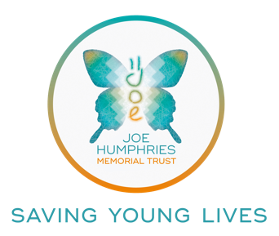

Title: | Full name: | Home Address & Postcode: (This is essential for Gift Aid. Please do not put your work address here) |  | Amount (£): | Date Paid:

Title: | Full name: | Home Address & Postcode: (This is essential for Gift Aid. Please do not put your work address here) |  | Amount (£): | Date Paid:

Title: | Full name: | Home Address & Postcode: (This is essential for Gift Aid. Please do not put your work address here) |  | Amount (£): | Date Paid:
Total amount raised (£):

